How to Measure

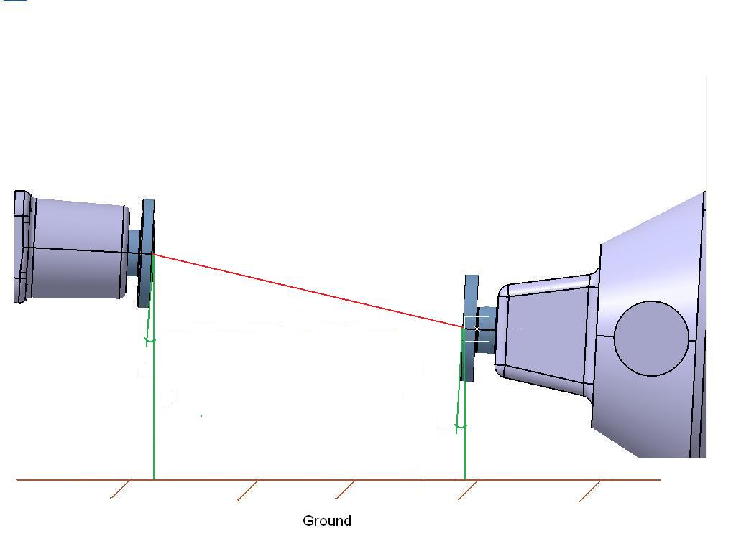
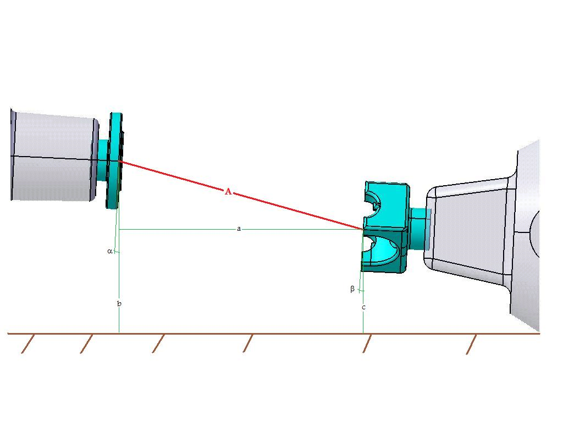
Style. 1(T-Flange to Center of U Joint) Style. 2(T-Flange to D-Flange)
a
A

A

1. Transfer case and pinion MUST be within 2 degrees of Parallel to each other
c
c
b
b
2. Circle which style: Style 1 Style 2
A. Determine length of the DRIVESHAFT: _________

Below measurements are optional
- Determine Parallel Distance: _________
Imaging a plum bob is hanging from each Flange Face (centerline), MEASURE the distance between the plum bob strings.

- Determine T-Case Shaft Height: _________
Measure from the ground to the (centerline) of T-Case output shaft.

- Determine T-Case Shaft Height: _________
Measure from the ground to the (centerline) of T-Case output shaft.

α Determine Angle of Transfer case: _________

ß Determine Angle of Differential: _________

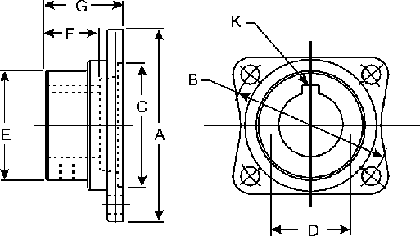
Define Flange

1.) Dimension C ______________
2.) Dimension B ______________
3.) Attaching bolt hole diameter ______________
a. Number of attaching bolts ______________
b. Equal bolt spacing? Yes/No (circle one)
C. If no define bolt spacing pattern: ___________
________________________________________________

