586-716-1160 www.ccidriveline.com

Ford Super Duty Drive Shaft Solution
Offered in 4” steel and 5” Aluminum
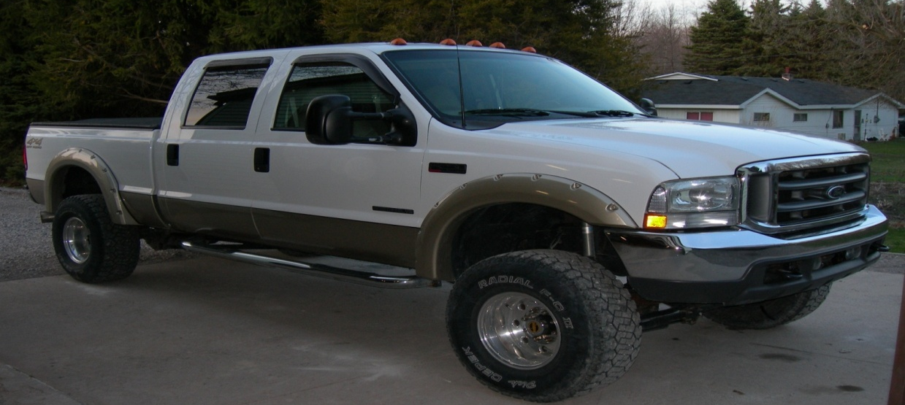

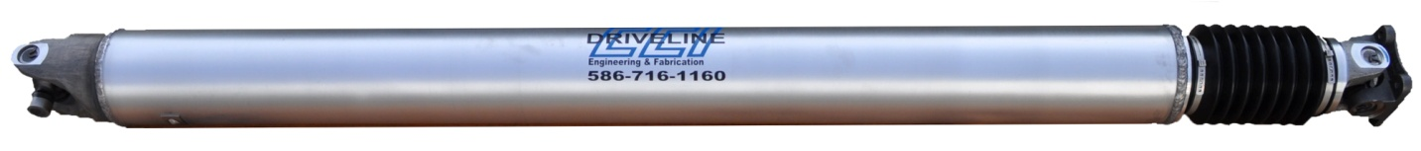

F-250 and F-350 Super duty Upgrade rear propeller shaft eliminates stock center support bearing
This drive shaft replaces the stock two-section drive shaft containing three u-joints and center bearing (the cause of most acceleration shudder issues), with a 5’’ single all aluminum drive shaft or 4” steel.
4” Super Duty Steel Driveshaft
Features:

- 4” x .083 wall tubing
- Built with Dana Spicer driveline components
Price w/ 1410 series
Single Flange Attachment………….……….$457.88
Double Flange Attachment………..………..$504.65

Price w/ 1480 series
*Single Flange Attachment……………...….$535.19
Double Flange Attachment………….……...$584.82
Note: Pinion yoke MUST be changed for single flange application

5’’ Super Duty Aluminum Driveshaft
- 6061 Aluminum
- Built with Dana Spicer and Sonnax driveline components

Price w/ 1350 u-joint at T-case and 1410 at Pinion
Single Flange Attachment…………………….$779.97
Double Flange Attachment……………….......$841.15

Price w/ 1410 series
Single Flange Attachment……………….…….$945.13
Double Flange Attachment………...……..…...$991.90

Price w/1480 Series
*Single Flange Attachment……………..……..$991.70
Double Flange Attachment……………………$1041.33
Note: Pinion yoke MUST be changed for single flange application

Note: Single flange is shown in above picture meaning one new flange yoke is supplied on product. Double flange yoke is not pictured and simply means that both the transfer case and the differential each mate to accepting flat flanges which are supplied on the drive shaft.
How to Measure

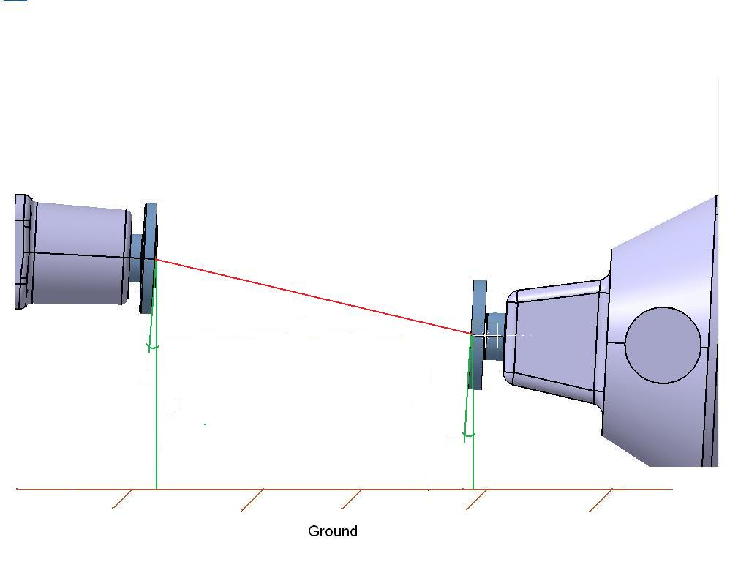
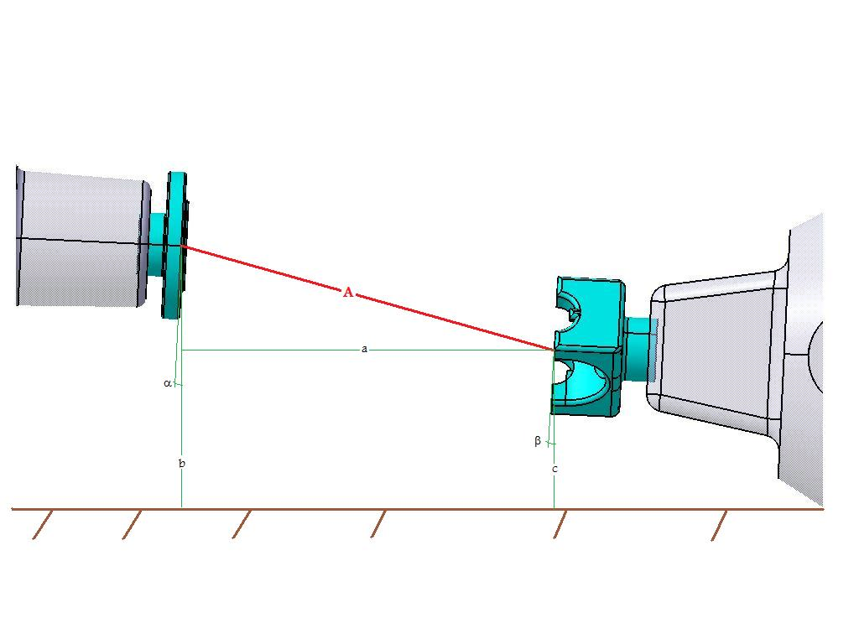
Style. 1(T-Flange to Center of U Joint) Style. 2(T-Flange to D-Flange)
a
A

A

1. Transfer case and pinion MUST be within 2 degrees of Parallel to each other
c
c
b
b
2. Circle which style: Style 1 Style 2
A. Determine length of the DRIVESHAFT: _________

Below measurements are optional
- Determine Parallel Distance: _________
Imaging a plum bob is hanging from each Flange Face (centerline), MEASURE the distance between the plum bob strings.

- Determine T-Case Shaft Height: _________
Measure from the ground to the (centerline) of T-Case output shaft.

- Determine T-Case Shaft Height: _________
Measure from the ground to the (centerline) of T-Case output shaft.

α Determine Angle of Transfer case: _________

ß Determine Angle of Differential: _________

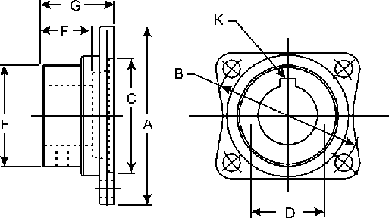
Define Flange

1.) Dimension C ______________
2.) Dimension B ______________
3.) Attaching bolt hole diameter ______________
a. Number of attaching bolts ______________
b. Equal bolt spacing? Yes/No (circle one)
C. If no define bolt spacing pattern: ___________
________________________________________________

